FACULTY PROFILE
K.ANUSHA  Department :Internet of Things Seshadri Rao Gudlavalleru Engineering College  Mobile:8330919896  E-Mail:kethinenianusha100@gmail.com  W/o M.Purna Mukesh, DNo:14/156,Railpet, Gudivada, Krishna District,  Andhra Pradesh:521301. | 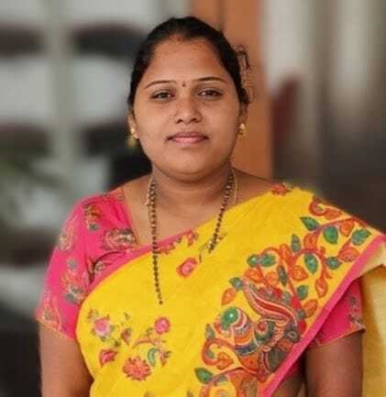

Academic Qualifications:

S. No | Name of the Degree | University | Percentage of Marks/CGPA | Specialization | Year of Pass
1 | M.Tech | AU | 8.87 | VLSI | 2018
2 | B.Tech | JNTUK | 77.4 | E.C.E | 2014
3 | Diploma | SBTET | 90.5 | D.E.C.E | 2011
4 | SSC | Board of Secondary Education | 77.12 | - | 2008

Professional Experience:

S. No. | Designation | Institution Name | Working Period
S. No. | Designation | Institution Name | From | To
1 | Assistant Professor | Seshadri Rao Gudlavalleru Engineering College | 30-10-2025 | Till date
2 | Assistant Professor | VKR, VNB & AGK College of Engineering, Gudivada | 30-05-2017 | 29-04-2023

Professional Body Membership:

S. No. | Name of the Professional body | Membership Number
1 | IEI (The Institution of Engineers (India) | AM165977-7

Paper Publications:
- K.Anusha, “Implementation of Reconfigurable CORDIC”, International Refereed Research Journal, Vol 3, Issue 6 November,2017.
- K.Anusha, “A Novel Methodology to Implement Sec Codes with Fast Decoding for a Subset of Critical Bits”,IJR Journal ,Volume VII,Issue XII,December-2018.

FDPS Attended :
- A one week FDP on “Application of Artificial Intelligence and soft computing Techniques to Electrical Engineering”,Organised by Dept. of Electrical Engineering , SRGEC Gudlavalleru, from13-11-2018 to 17-11-2018.
- A Five day National Level online FDP on “Modern Research Trends in communication, signal processing and VLSI” Organised by Dept. of ECE Andhra Loyola Institute of Engineering and Technology, during 19-05-2020 to 23-05-2020.
- A Five day National Level online FDP on “Recent Trends in communication and wireless networks” Organised by Dept. of ECE at KKR & KSR institute of technology and science, during 05-06-2020 to 09-06-2020.
- A One week Faculty development program on "Principles of Modern RADAR" Organised by the Department of Electronics and Communication Engineering ,RISE Krishna sai prakasam Group of Institutions, Ongole in association with ISTE chapter from 03-06-2020 to 07-06-2020.
- A Five day National Level online FDP on “Recent Trends and Research Areas in Applied VLSI and Advanced Communications” organized by the Department of ECE from 08-06-2020 to12-06-2020.
- NPTEL-AICTE FDP on “CMOS Digital VLSI Design”.
- NPTEL-AICTE FDP on “System Design through VERILOG”.

Workshops/Webinars/Conferences/Attended:
- Participation in Two-Day Workshop on “Internet Of Things”, organized by VKR,VNB & AGK College Of Engineering conducted from 28-9-2020 to 29-9-2020 organized by Robokart.com & Innovation-Cell UMIC,IIT Bombay.
- Participated in First International Conference on “Computational and Intelligent Techniques for Automation of Engineering Systems” Nov-30- Dec1,2018 organized by Gudlavalleru Engineering College.

NPTEL Certifications:
- CMOS Digital VLSI Design 79%(Elite + Silver)
- System Design Through Verilog 72% (Elite)

Projects guided:
- Anti-smuggling of sandal wood trees using Wireless Sensor Networks.
- IoT Based Smart Vehicle Parking System using RFID.
- Real time Control System for Air Pollution Detection in Vehicles.
- Human Following ROBOT controlled with Wearable Device.

Subjects Handled:
- Analog Communications
- Electronic Devices and Circuits
- Linear IC and Applications
- Embedded Systems
- Electronic Measurements and Instrumentation

Labs Handled:
- Electronic Devices and Circuits
- Communications
- Digital IC Applications
- Linear IC Applications

Declaration
I hereby declare that all the above-furnished information is correct to the best of my knowledge.

Date:13-12-2025 Signature

Place: Gudivada K.Anusha

